BCT 2408 Lab2
Enoch Teddy
SCT212-0078/2021
E1:
Solution
a. No forwarding and branch optimization
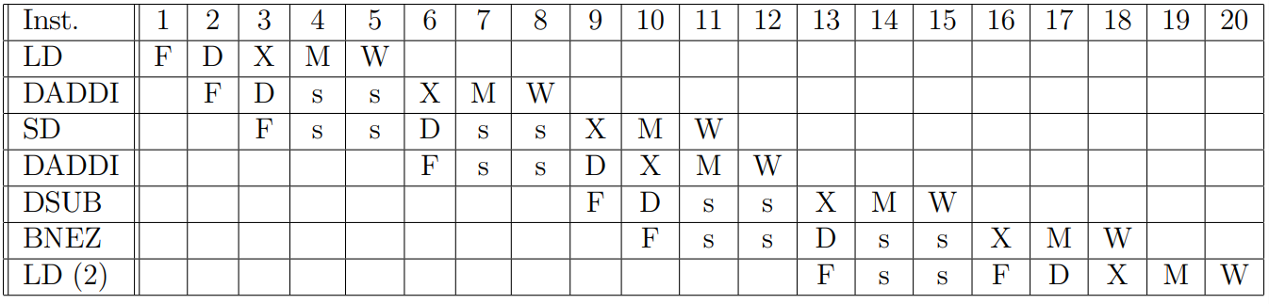
• The first DADDI must wait until LD gets to the WB stage to obtain the value of R1.
• SD must wait until the first DADDI computes the value of R1 and reaches the WB stage (no forwarding).
• DSUB must wait until the second DADDI computes the value of R2 and reaches the WB stage.
• BNEZ must wait until DSUB computes the value of R4 and reaches the WB stage.
• LD from the next iteration is re-fetched after the branch is resolved as taken (in the branch ID stage).
The loop executes 99 iterations (396/4), iterations 0 to 98.
Total Cycles = (98 × 15) + 18 = 1,488 cycles
b. Forwarding and branch predict not taken
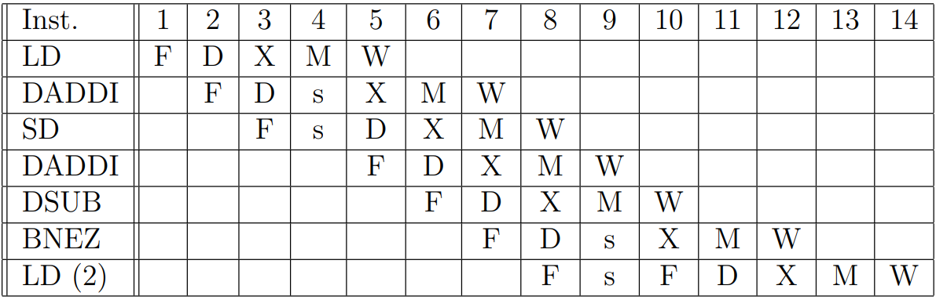
• The first ADDI still must wait until LD gets to the WB stage to obtain the value of R1, but now stall is implemented in the EX stage through the interlocking mechanism and value is forwarded directly to EX stage.
• SD now waits until the first ADDI computes the value of R1 and forwards the value from EX to MEM.
• DSUB now gets the value of R2 forwarded by the second ADDI and does not need to wait.
• BNEZ now gets the value of R4 forwarded by sub but needs to wait till the sub reaches EX stage.
• LD from the next iteration is re-fetched after the branch is resolved as mispredicted (in the branch ID stage).
Iteration i now begins in cycle 1 + (i ∗ 9) and the last iteration takes only 12 cycles to complete
c. Simple instruction scheduling and branch delay slot
• Optimization 1: move the second DADDI to the load delay slot.
• Optimization 2: move DSUB up, to after the second DADDI.
• Optimization 3: move SD to the branch delay slot, adjusting the offset (SD -4(R2),R1)
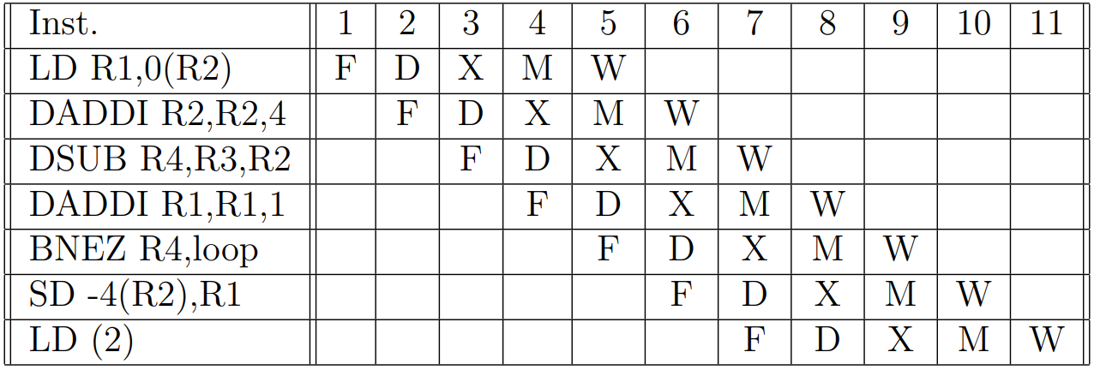
• The first DADDI does not wait as it is now separated by two extra cycles from LD.
• The BNEZ now does not wait as it is separated by one extra cycle from DSUB.
• SD now fills the branch delay slot.
• LD from the next iteration is properly fetched as the branch is resolved in time.
Iteration i now begins in cycle 1 + (i ∗ 6) and the last iteration takes only 10 cycles to complete
Total: (98 × 6) + 10 = 598 cycles

